New Features Flex

<https://codepen.io/jonasschmedtmann/pen/LXydvq>

aim to design below webpage

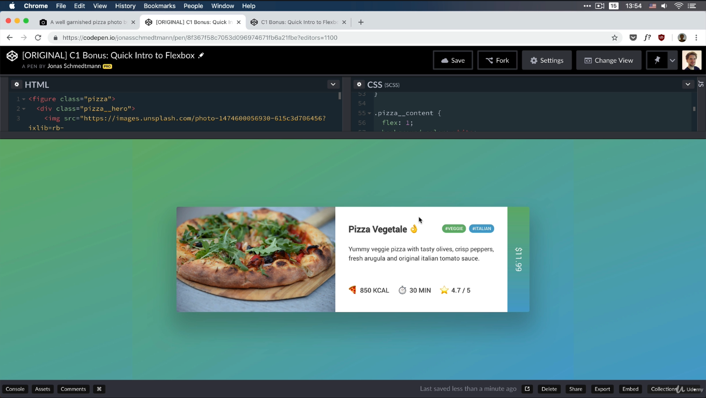

introduction

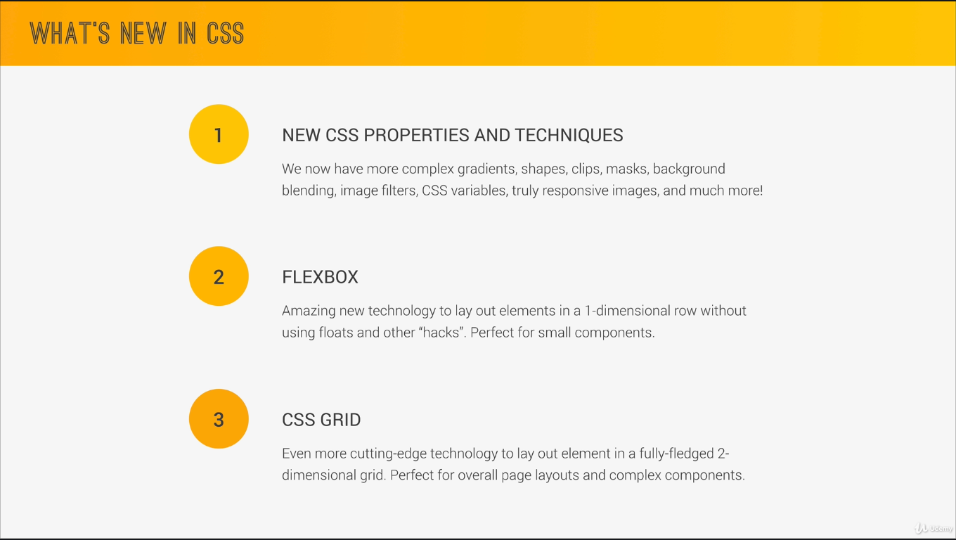

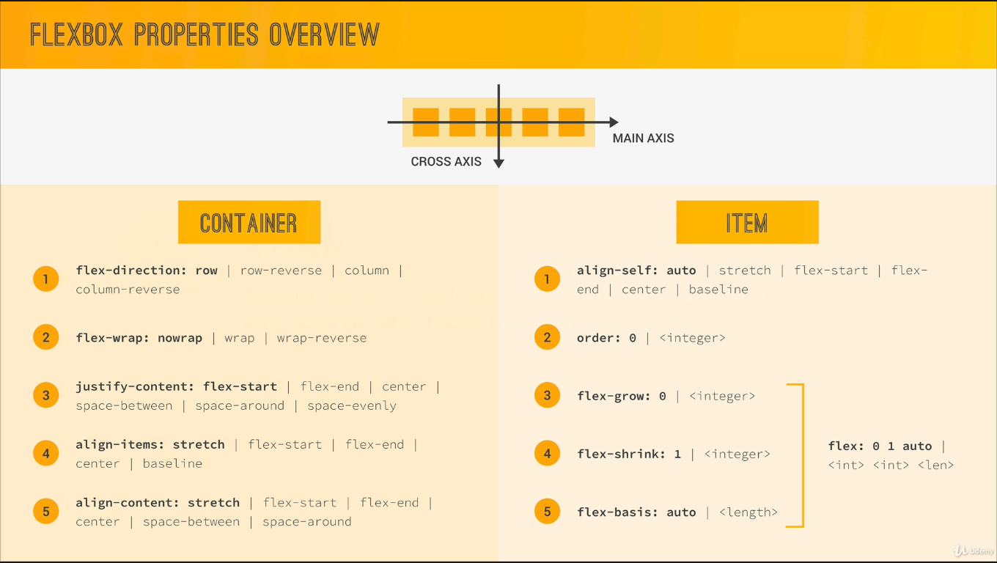

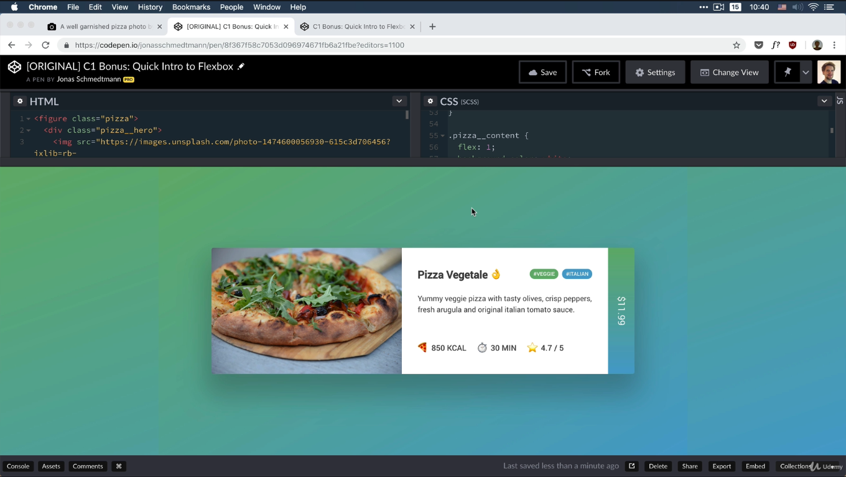 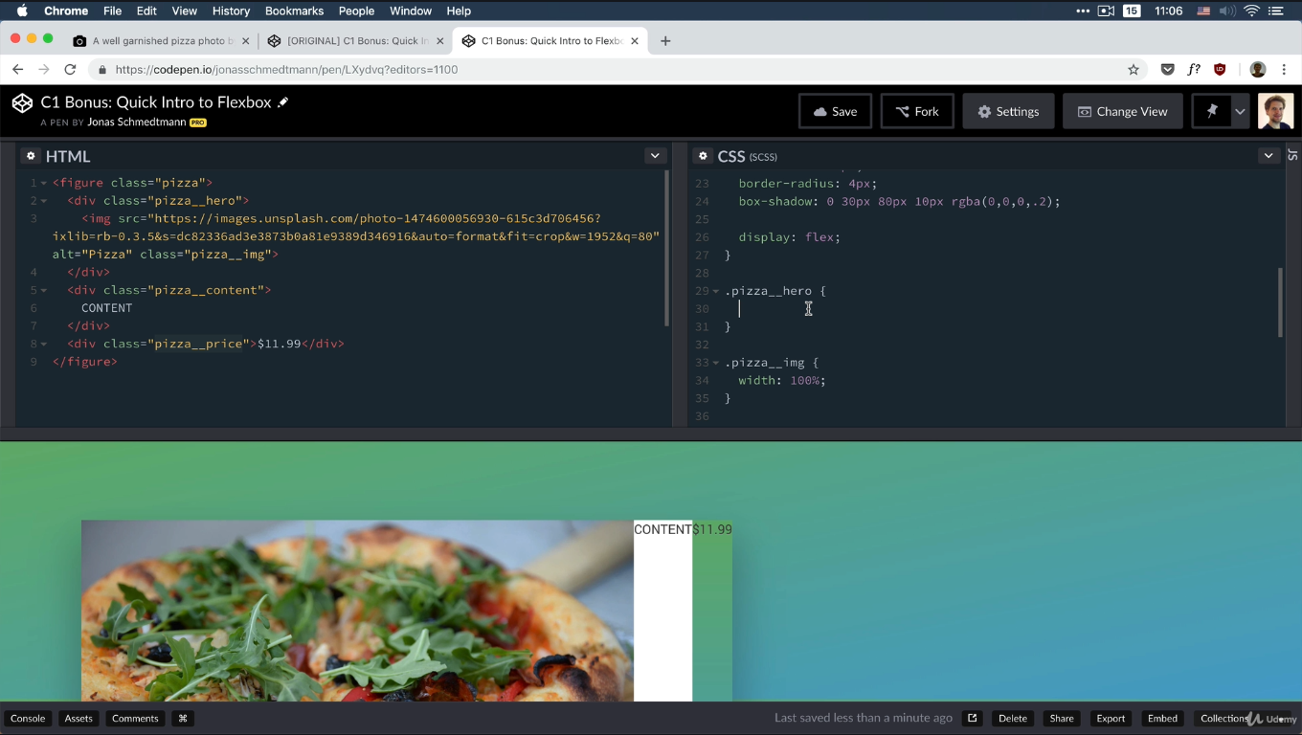



flex: *flex-grow* *flex-shrink* *flex-basis*|auto|initial|inherit;

|  |  |
| --- | --- |
| **Value** | **Description** |
| [*flex-grow*](https://www.w3schools.com/cssref/css3_pr_flex-grow.asp) | A number specifying how much the item will grow relative to the rest of the flexible items |
| [*flex-shrink*](https://www.w3schools.com/cssref/css3_pr_flex-shrink.asp) | A number specifying how much the item will shrink relative to the rest of the flexible items |
| [*flex-basis*](https://www.w3schools.com/cssref/css3_pr_flex-basis.asp) | The length of the item. Legal values: "auto", "inherit", or a number followed by "%", "px", "em" or any other length unit |

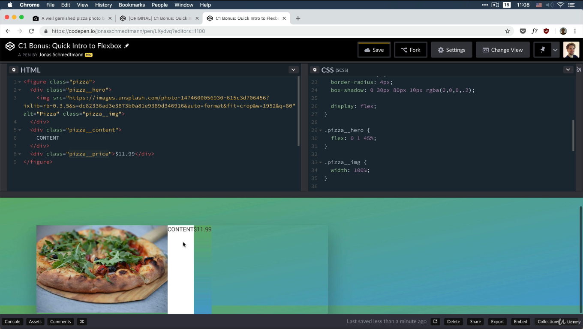

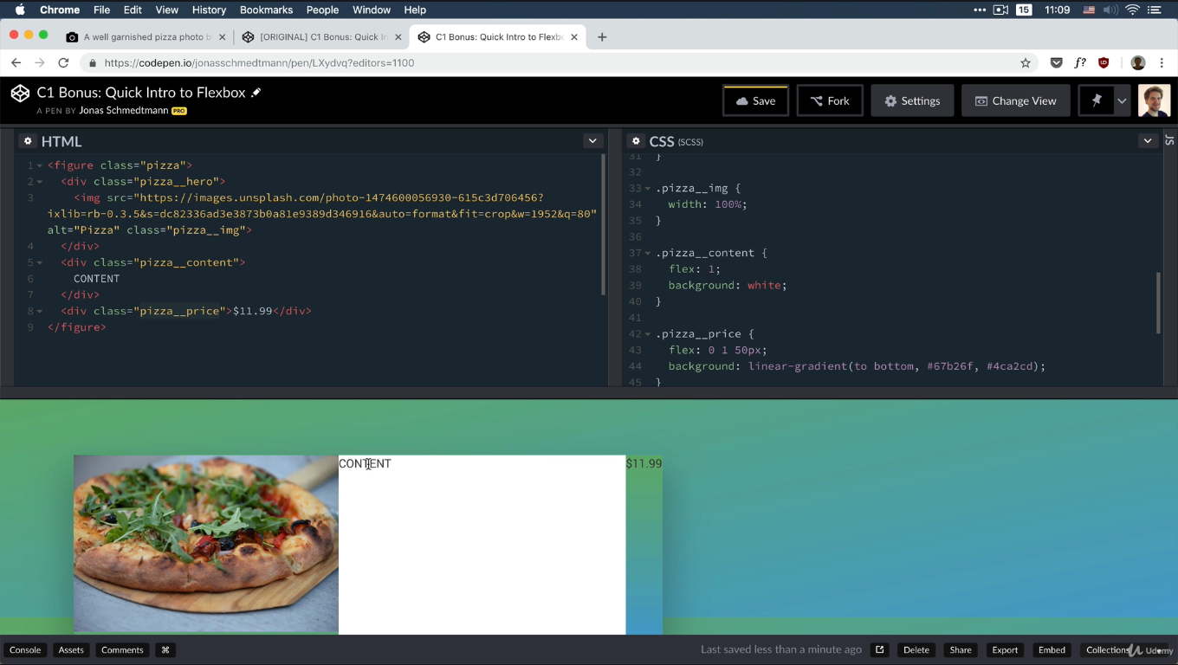

Flex: 1 or flex-grow:1 both are same

Flex : 0 0 45% or flow-basis: 45% both are same

align-items : center default is stretch

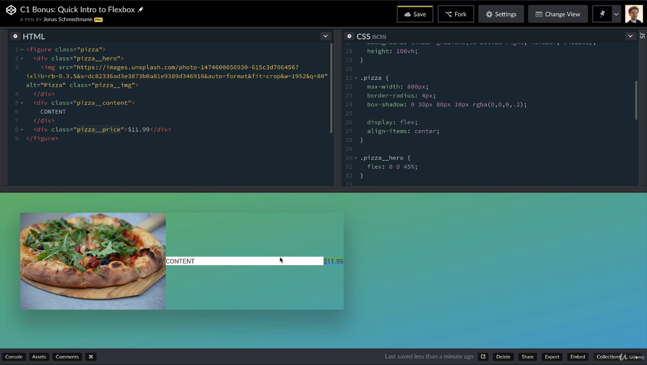

Align-self:center

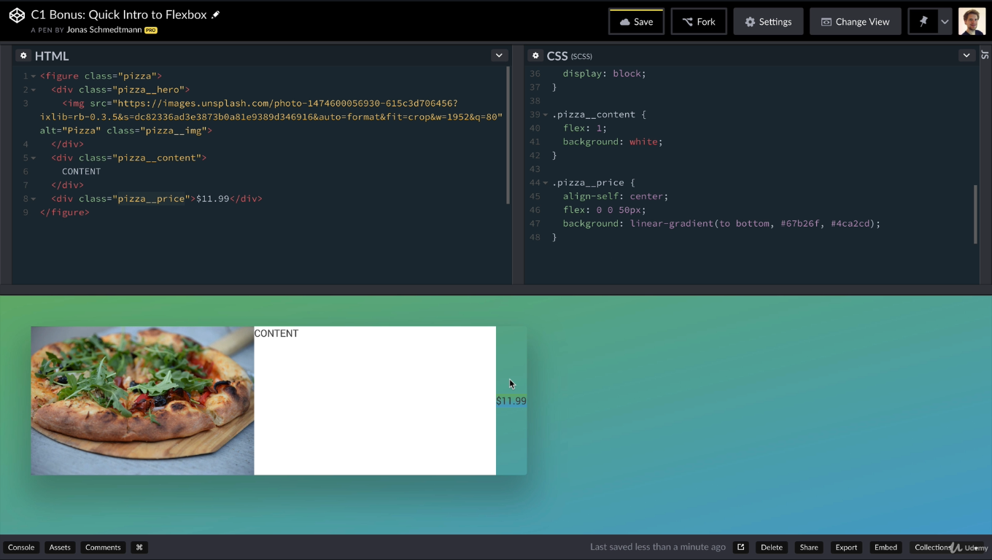

Align-items:center //cross-axis

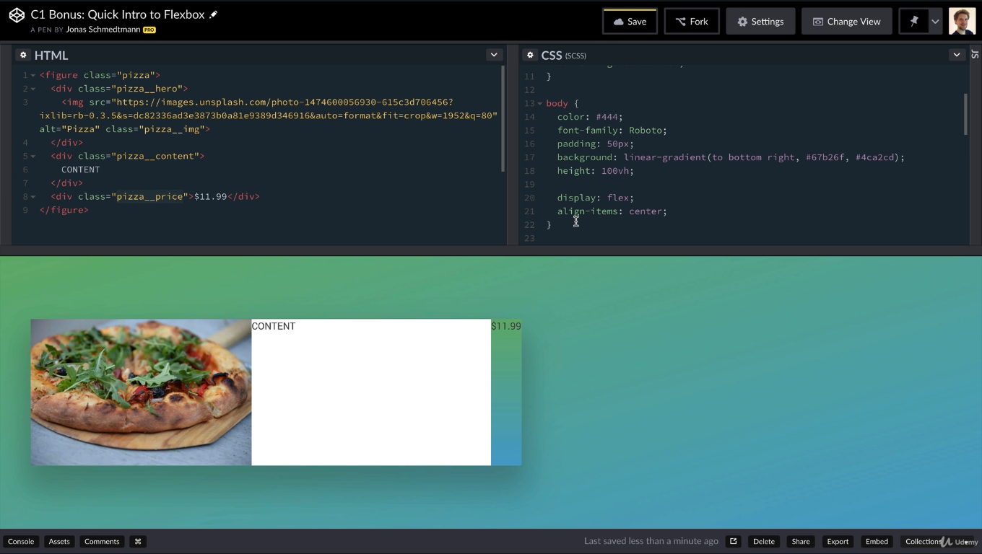

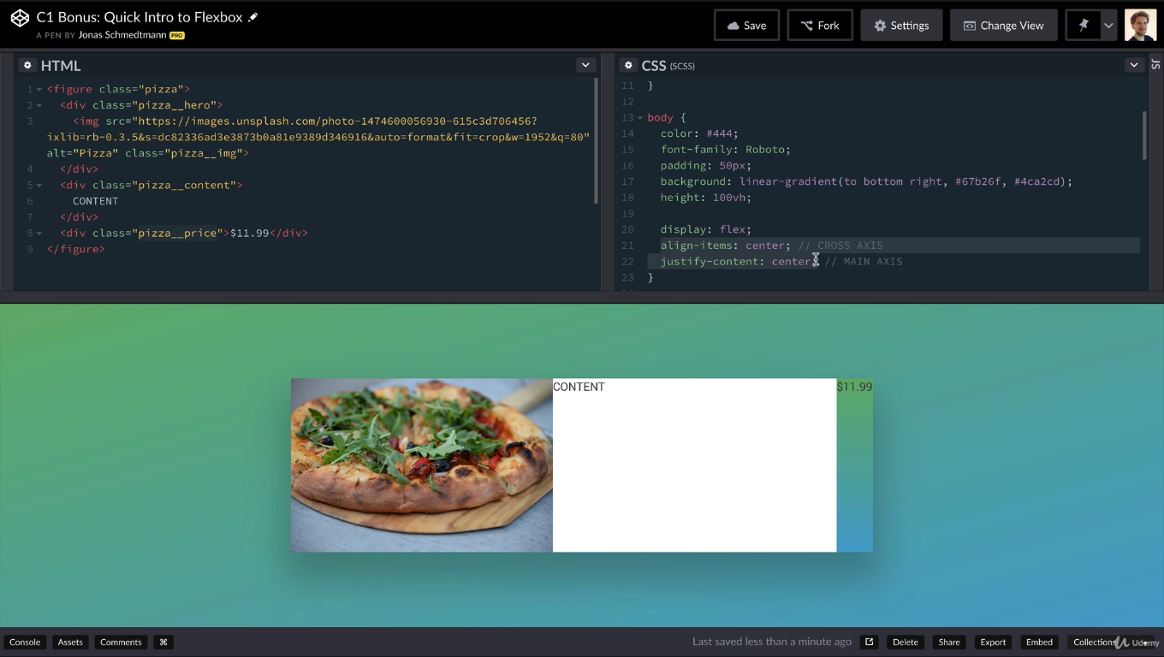

Wirting-mode

